**Week-3**

Spring Data JPA with Spring Boot, Hibernate

**Spring Data JPA - Quick Example**

* Go to <https://start.spring.io/>
* Change Group as “com.cognizant”
* Change Artifact Id as “orm-learn”
* Click on menu and select "Spring Boot DevTools", "Spring Data JPA" and "MySQL Driver"

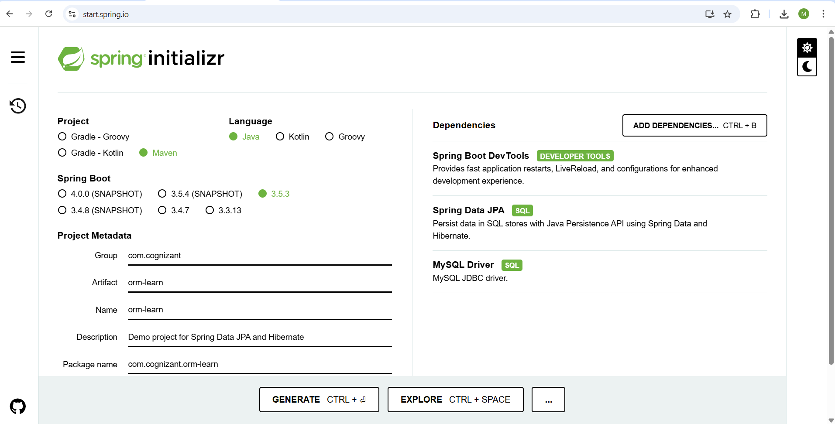

* Click Generate and download the project as zip
* Extract the zip in root folder to Eclipse Workspace
* Import the project in Eclipse "File > Import > Maven > Existing Maven Projects > Click Browse and select extracted folder > Finish"
* Create a new schema "ormlearn" in MySQL database. Execute the following commands to open MySQL client and create schema.

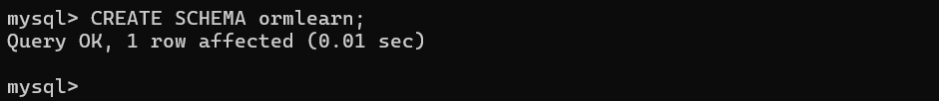

* In orm-learn Eclipse project, open src/main/resources/application.properties and include the below database and log configuration.

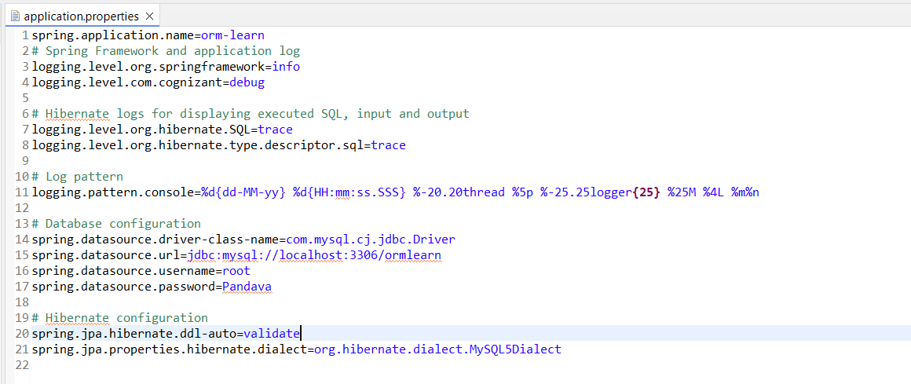

* Include logs for verifying if main() method is called.
* Country table creation

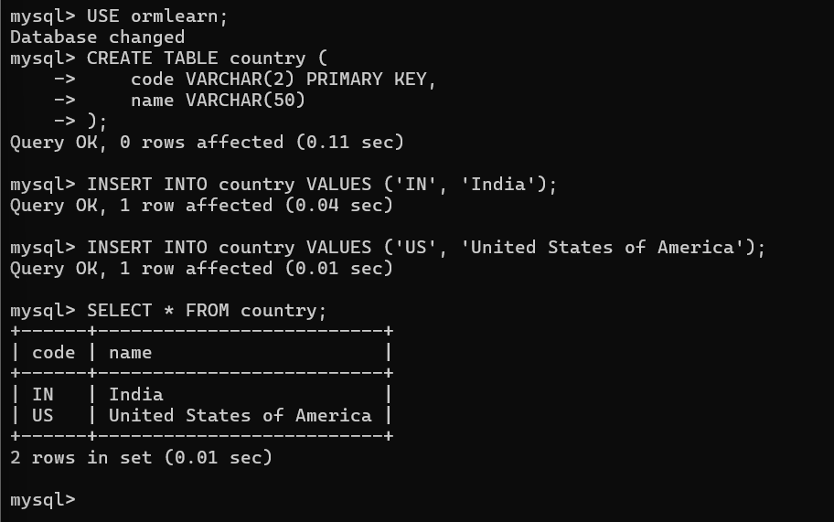

* Inside com.cognizant.orm_learn, create new package called model.Inside that,crate a new class

**package** com.cognizant.orm_learn.model;

**import** jakarta.persistence.Column;

**import** jakarta.persistence.Entity;

**import** jakarta.persistence.Id;

**import** jakarta.persistence.Table;

@Entity

@Table(name = "country")

**public** **class** Country {

@Id

@Column(name = "code")

**private** String code;

@Column(name = "name")

**private** String name;

// Getters and Setters

**public** String getCode() {

**return** code;

}

**public** **void** setCode(String code) {

**this**.code = code;

}

**public** String getName() {

**return** name;

}

**public** **void** setName(String name) {

**this**.name = name;

}

// toString

@Override

**public** String toString() {

**return** "Country [code=" + code + ", name=" + name + "]";

}

}

* Inside com.cognizant.orm_learn , create new package called repository .Inside that,create a new class

**package** com.cognizant.orm_learn.repository;

**import** org.springframework.data.jpa.repository.JpaRepository;

**import** org.springframework.stereotype.Repository;

**import** com.cognizant.orm_learn.model.Country;

@Repository

**public** **interface** CountryRepository **extends** JpaRepository<Country, String> {

}

* Inside com.cognizant.orm_learn , create new package called service.Inside that,create a new class

**package** com.cognizant.orm_learn.service;

**import** java.util.List;

**import** jakarta.transaction.Transactional;

**import** org.springframework.beans.factory.annotation.Autowired;

**import** org.springframework.stereotype.Service;

**import** com.cognizant.orm_learn.model.Country;

**import** com.cognizant.orm_learn.repository.CountryRepository;

@Service

**public** **class** CountryService {

@Autowired

**private** CountryRepository countryRepository;

@Transactional

**public** List<Country> getAllCountries() {

**return** countryRepository.findAll();

}

}

* **Pom.xml:**

<?xml version="1.0" encoding="UTF-8"?>

<project xmlns="http://maven.apache.org/POM/4.0.0" xmlns:xsi="http://www.w3.org/2001/XMLSchema-instance"

xsi:schemaLocation="http://maven.apache.org/POM/4.0.0 https://maven.apache.org/xsd/maven-4.0.0.xsd">

<modelVersion>4.0.0</modelVersion>

<parent>

<groupId>org.springframework.boot</groupId>

<artifactId>spring-boot-starter-parent</artifactId>

<version>3.5.3</version>

<relativePath/> <!-- lookup parent from repository -->

</parent>

<groupId>com.cognizant</groupId>

<artifactId>orm-learn</artifactId>

<version>0.0.1-SNAPSHOT</version>

<name>orm-learn</name>

<description>Demo project for Spring Data JPA and Hibernate</description>

<url/>

<licenses>

<license/>

</licenses>

<developers>

<developer/>

</developers>

<scm>

<connection/>

<developerConnection/>

<tag/>

<url/>

</scm>

<properties>

<java.version>17</java.version>

</properties>

<dependencies>

<dependency>

<groupId>org.springframework.boot</groupId>

<artifactId>spring-boot-starter-data-jpa</artifactId>

</dependency>

<dependency>

<groupId>org.springframework.boot</groupId>

<artifactId>spring-boot-devtools</artifactId>

<scope>runtime</scope>

<optional>true</optional>

</dependency>

<dependency>

<groupId>com.mysql</groupId>

<artifactId>mysql-connector-j</artifactId>

<scope>runtime</scope>

</dependency>

<!-- Spring Boot Starter JPA -->

<dependency>

<groupId>org.springframework.boot</groupId>

<artifactId>spring-boot-starter-data-jpa</artifactId>

</dependency>

<dependency>

<groupId>org.springframework.boot</groupId>

<artifactId>spring-boot-starter-test</artifactId>

<scope>test</scope>

</dependency>

<dependency>

<groupId>jakarta.transaction</groupId>

<artifactId>jakarta.transaction-api</artifactId>

<version>2.0.1</version>

<dependency>

<groupId>org.springframework.boot</groupId>

<artifactId>spring-boot-starter-data-jpa</artifactId>

</dependency>

</dependency>

</dependencies>

<build>

<plugins>

<plugin>

<groupId>org.springframework.boot</groupId>

<artifactId>spring-boot-maven-plugin</artifactId>

</plugin>

</plugins>

</build>

</project>

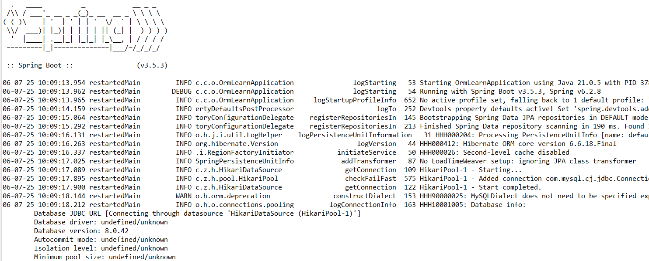

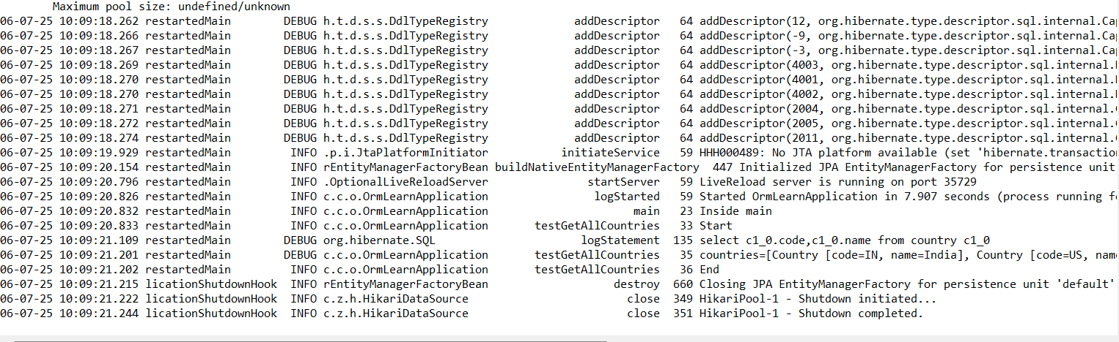

**Difference between JPA, Hibernate and Spring Data JPA**

* Go to <https://start.spring.io/>
* Change Group as “com.cognizant”
* Change Artifact Id as “orm-learn”
* Click on menu and select "Spring Boot DevTools", "Spring Data JPA" and "MySQL Driver"



* Click Generate and download the project as zip
* Extract the zip in root folder to Eclipse Workspace
* Import the project in Eclipse "File > Import > Maven > Existing Maven Projects > Click Browse and select extracted folder > Finish"
* Create a new schema "ormlearn" in MySQL database. Execute the following commands to open MySQL client and create schema.

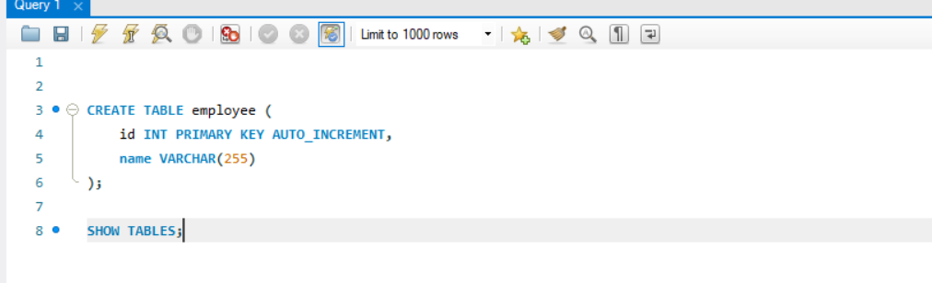

* Inside com.cognizant.orm_model , create new package called model.Inside that,crate a new class

**package** com.cognizant.orm_learn.model;

**import** jakarta.persistence.*;

@Entity

@Table(name = "employee")

**public** **class** Employee {

@Id

@GeneratedValue(strategy = GenerationType.***IDENTITY***)

**private** **int** id;

**private** String name;

**public** Employee() {}

**public** Employee(**int** id, String name) {

**this**.id = id;

**this**.name = name;

}

**public** **int** getId() {

**return** id;

}

**public** **void** setId(**int** id) {

**this**.id = id;

}

**public** String getName() {

**return** name;

}

**public** **void** setName(String name) {

**this**.name = name;

}

}

* Inside com.cognizant.orm_learn , create new package called service.Inside that,create a new class

**package** com.cognizant.orm_learn.service;

**import** org.springframework.beans.factory.annotation.Autowired;

**import** org.springframework.stereotype.Service;

**import** com.cognizant.orm_learn.model.Employee;

**import** com.cognizant.orm_learn.repository.EmployeeRepository;

**import** jakarta.transaction.Transactional;

**import** java.util.List;

**import** java.util.Optional;

@Service

**public** **class** EmployeeService {

@Autowired

**private** EmployeeRepository employeeRepository;

@Transactional

**public** **void** addEmployee(Employee employee) {

**if** (employee.getId() != 0) {

Optional<Employee> existingEmployee = employeeRepository.findById(employee.getId());

**if** (existingEmployee.isPresent()) {

Employee emp = existingEmployee.get();

emp.setName(employee.getName());

employeeRepository.save(emp);

System.***out***.println("Updated Employee with ID: " + emp.getId());

} **else** {

System.***out***.println("Employee with ID " + employee.getId() + " does not exist. Inserting new employee...");

employee.setId(0);

Employee saved = employeeRepository.save(employee);

System.***out***.println("Inserted new Employee with ID: " + saved.getId());

}

} **else** {

Employee saved = employeeRepository.save(employee);

System.***out***.println("Inserted new Employee with ID: " + saved.getId());

}

}

**public** Employee getEmployee(**int** id) {

**return** employeeRepository.findById(id)

.orElseThrow(() -> **new** RuntimeException("Employee not found with ID: " + id));

}

**public** List<Employee> getAllEmployees() {

**return** employeeRepository.findAll();

}

}

* Inside com.cognizant.orm_learn , create new package called repository .Inside that,create a new class

**package** com.cognizant.orm_learn.repository;

**import** org.springframework.data.jpa.repository.JpaRepository;

**import** com.cognizant.orm_learn.model.Employee;

**public** **interface** EmployeeRepository **extends** JpaRepository<Employee, Integer> {

}

* In src/main/resources , add the below code in application.properties

spring.application.name=orm-learn

# Spring Framework and application log

logging.level.org.springframework=info

logging.level.com.cognizant=debug

# Hibernate logs for displaying executed SQL, input and output

logging.level.org.hibernate.SQL=trace

logging.level.org.hibernate.type.descriptor.sql=trace

# Log pattern

logging.pattern.console=%d{dd-MM-yy} %d{HH:mm:ss.SSS} %-20.20thread %5p %-25.25logger**{25}** %25M %4L %m%n

# Database configuration

spring.datasource.driver-class-name=com.mysql.cj.jdbc.Driver

spring.datasource.url=jdbc:mysql://localhost:3306/ormlearn

spring.datasource.username=root

spring.datasource.password=Pandava

# Hibernate configuration

spring.jpa.hibernate.ddl-auto=update

spring.jpa.database-platform=org.hibernate.dialect.MySQLDialect

